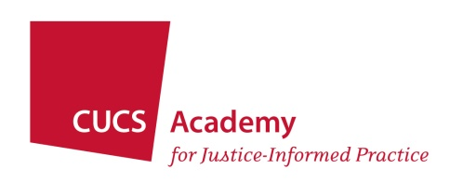

UNDERSTANDING MEDICATIONS FOR SUBSTANCE USE AND MENTAL HEALTH DISORDERS FOR TREATMENT COURT PARTICIPANTS

Written Materials
Friday, April 12, 2024
1:00 pm – 2:30 pm
Online Webinar

Substance Abuse and Mental Health Services Administration, SAMHSA’s Working Definition of Recovery (2012)
https://store.samhsa.gov/sites/default/files/pep12-recdef.pdf

American Association of Psychiatric Pharmacists, Adherence (2019)
https://nami.org/NAMI/media/NAMI-Media/Research/Medication-Adherence_2022.pdf

American Association of Psychiatric Pharmacists, What To Expect from Your Medications (2018)
https://nami.org/NAMI/media/NAMI-Media/Research/What-to-Expect-from-Your-Medications_2022.pdf

American Association of Psychiatric Pharmacists, What You Need to Know about Long Acting Injectibles (2022)
https://nami.org/NAMI/media/NAMI-Media/Research/Long-Acting-Injectables_2022.pdf

Note: The publications from the American Association of Psychiatric Pharmacists listed above are available on the website of the National Alliance on Mental Illness (NAMI). That website has numerous other articles that mental health court teams will find useful, including:

Mental Health Medications [an overview]
https://nami.org/About-Mental-Illness/Treatments/Mental-Health-Medications

Types of Medications
https://nami.org/About-Mental-Illness/Treatments/Mental-Health-Medications/Types-of-Medication

Legal Action Center, Center for Court Innovation, and the New York State Unified Court System, Medication-Assisted Treatment in Drug Courts: Recommended Strategies (2015)
https://www.innovatingjustice.org/publications/medication-assisted-treatment-drug-courts-recommended-strategies

Rivers v. Katz, 67 N.Y.2d 485, 495 N.E.2d 337, 504 N.Y.S.2d 74 (1986)
https://scholar.google.com/scholar_case?case=12167532942286784057&q=rivers+v+katz&hl=en&as_sdt=4,33

Sell v. United States, 539 U.S. 166 (2003)
https://scholar.google.com/scholar_case?case=10071406451224631321&q=sell+v.+united+state+2003&hl=en&as_sdt=6,33&as_vis=1

